|  |
| --- |
|  |
|  |

|  |  |  |  |  |  |
| --- | --- | --- | --- | --- | --- |
| REVISION HISTORY | | | | | |
| Ver. | Description of Change | Author | Date | Approved | |
| Name | Effective Date |
| 1.0 | Initial status | [Kiryl Bucha](mailto:Kiryl_Bucha@epam.com) | 12-JAN-2012 |  |  |
| 2.0 | Updated in accordance with renewed content | [Elias Nema](mailto:Elias_Nema@epam.com) | 20-JAN-2014 |  |  |
| 3.0 | Report | Mikita Tur | 10-DEC-2017 |  |  |

Contents

1. Create Packages for Reload Dimension from SA_* 3

2. Task Results 3

# Create packages to load dimensions from source to staging (3NF) layer

* Create all required dim objects on ST Layer (T_...).

On the 3NF layer necessary tables and sequences were created.

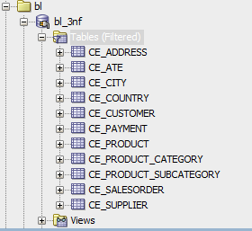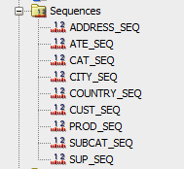

3NF Scheme:

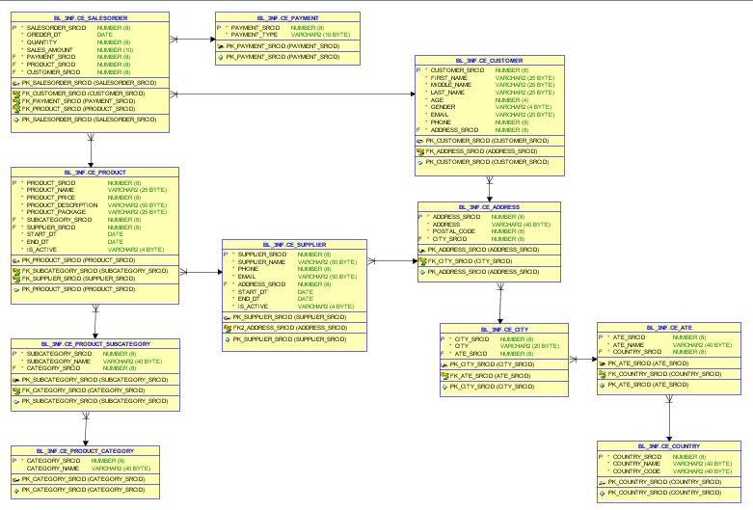

Grants:

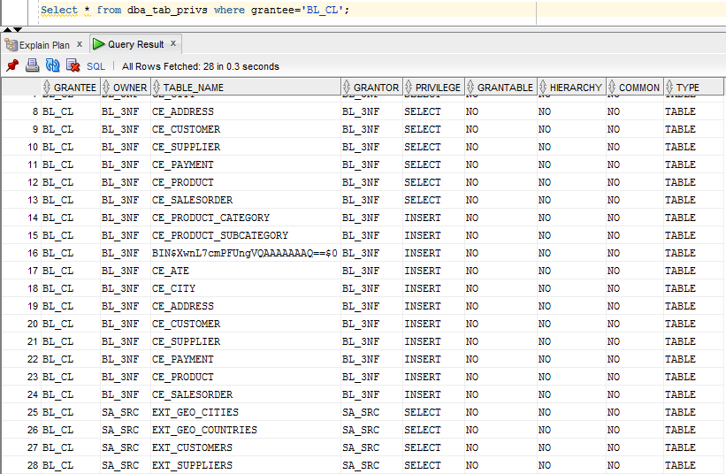

All Inserts and Merges into bl_3nf layer are situated in CLS folder:

_0. DWH\Projects\Mikita_Tur\dwso\bl_cl\package\CLS

Explicit Cursor:

PROCEDURE insert_table_cls_product_subcategory

IS

CURSOR my_cursor

IS

SELECT DISTINCT NVL(subcategory,'-99') as Subcategory_name, NVL(CATEGORY,'-99') as category_name

FROM wrk_products ;

pm_my_cursor cls_product_subcategory%rowtype;

BEGIN

EXECUTE IMMEDIATE 'TRUNCATE TABLE ‘cls_product_subcategory’;

OPEN my_cursor;

LOOP

FETCH my_cursor INTO pm_my_cursor;

IF my_cursor%found THEN

INSERT

INTO cls_product_subcategory

INSERT INTO cls_product_subcategory

(

subcategory_name,

CATEGORY_NAME

)

VALUES

(

pm_emp_cursor. Subcategory_name,

pm_emp_cursor.category_name

) ;

END IF;

EXIT

WHEN my_cursor%notfound;

END LOOP;

COMMIT;

CLOSE my_cursor;

COMMIT;

EXCEPTION

WHEN OTHERS THEN

RAISE;

END insert_cls_product_subcategory;

Implicit Cursor:

PROCEDURE INSERT_TABLE_ATE

IS

BEGIN

EXECUTE IMMEDIATE ('TRUNCATE TABLE CLS_ATE');

INSERT INTO CLS_ATE(ATE_NAME,COUNTRY_code)

SELECT * FROM (SELECT distinct(nvl(STATEFULL,'-99')),country

FROM WRK_CUSTOMERS CUST

UNION

SELECT distinct(nvl(STATEFULL,'-99')),country

FROM WRK_SUPPLIERS);

COMMIT;

EXCEPTION WHEN OTHERS THEN RAISE;

END INSERT_TABLE_ATE;

Merge:

CREATE OR REPLACE PACKAGE BODY PKG_ETL_INSERT_COUNTRY

AS

PROCEDURE INSERT_TABLE_COUNTRY

IS

BEGIN

EXECUTE IMMEDIATE ('TRUNCATE TABLE CLS_COUNTRY');

INSERT INTO CLS_COUNTRY(country_name, country_code)

SELECT COUN.COUNTRY_NAME,COUN.CC_FIPS

FROM WRK_COUNTRIES COUN LEFT JOIN WRK_CUSTOMERS COS

ON (COUN.COUNTRY_NAME = COS.COUNTRYFULL );

COMMIT;

EXCEPTION WHEN OTHERS THEN RAISE;

END INSERT_TABLE_COUNTRY;

---

PROCEDURE MERGE_TABLE_COUNTRY

IS

BEGIN

MERGE INTO bl_3nf.ce_country CEC using

(SELECT

COUNTRY_SRCID,

COUNTRY_NAME,

COUNTRY_CODE

FROM CLS_COUNTRY

MINUS

SELECT

COUNTRY_SRCID,

COUNTRY_NAME,

COUNTRY_CODE

FROM bl_3nf.ce_country

) CLSC ON (CLSC.COUNTRY_SRCID = CEC.COUNTRY_SRCID)

WHEN MATCHED THEN

UPDATE SET CEC.COUNTRY_NAME = CLSC.COUNTRY_NAME

WHEN NOT MATCHED THEN

INSERT

(

COUNTRY_SRCID,

COUNTRY_NAME,

COUNTRY_CODE

)

VALUES

(

bl_3nf.COUNTRY_SEQ.NEXTVAL,

CLSC.COUNTRY_NAME,

CLSC.COUNTRY_CODE

);

COMMIT;

EXCEPTION

WHEN OTHERS THEN RAISE ;

END MERGE_TABLE_COUNTRY;

END PKG_ETL_INSERT_COUNTRY;

/

